WORKING DRAFT — NOT FOR USE
Sideline Screen / Duck Blind
Construction and Field Operations Manual
The nominal 4 ft x 8 ft sideline screen provides the color guard with a concealed area for storing equipment and making costume or equipment changes. The frame is constructed from 3/4-in. EMT conduit, off-the-shelf brackets, and 3D-printed parts. Decorative vinyl covers the finished face. The completed screen folds flat for transport and storage and unfolds for field deployment.
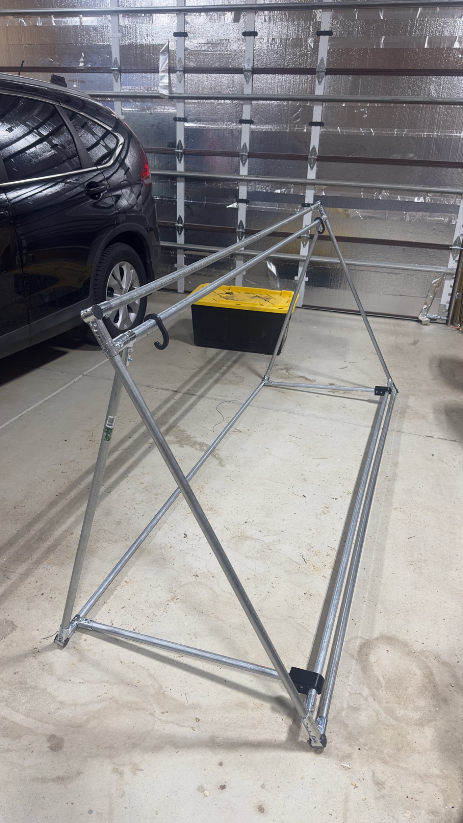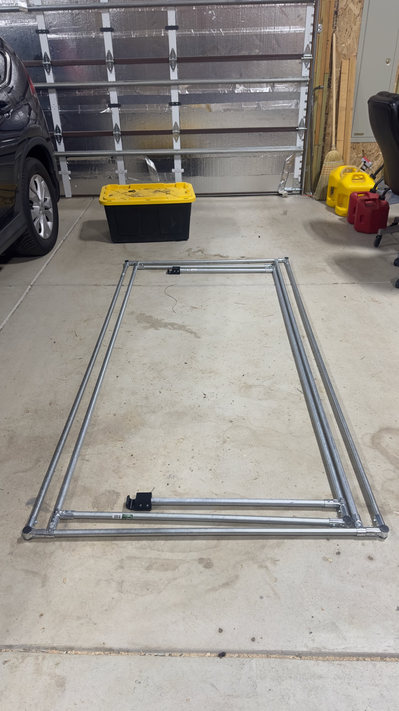
Screen shown deployed and folded for storage.
Release v0 (unreleased) | Development build D25 | September 1, 2026
Version | Date | Status | One-line description
D24 | 2026-09-01 | Working draft | Imported legacy v24 draft as controlled baseline D24
D25 | 2026-09-01 | Working draft | Standardized status markings, footers, and added visible version history table

Intro / Overview
This master manual is organized as two independently printable appendices under a shared overview. The appendix letter in each header and page number identifies the complete print unit.

Appendix A: Operations Manual
Field-facing copy for transport, deployment, ballasting, post-use inspection, and storage. A field operator should need only the pages labeled A- once the procedures are validated and released.

Appendix B: Construction Manual
Shop-facing copy for materials, cutting, frame assembly, vinyl installation, inspection, and source lookup. The component-source index is located at the end of Appendix B and applies only to that appendix.

Printing and separation
Appendix A print unit: Print or extract every page labeled A-. Its cover identifies the parent manual and revision.
Appendix B print unit: Print or extract every page labeled B-. Its cover and index remain with the construction packet.
Master copy: Keep this Intro / Overview with the complete document so the relationship between both appendices remains clear.
Working-draft status: Appendix A is structurally ready to separate, but its operating procedures are still development notes and must not yet be issued for field use. Appendix B's frame-construction procedure is illustrated; its vinyl-installation procedure remains incomplete.

PART OF THE SIDELINE SCREEN / DUCK BLIND CONSTRUCTION AND FIELD OPERATIONS MANUAL
APPENDIX A
Operations Manual
Field transport, deployment, ballasting, inspection, and storage
This appendix is designed as a complete, independently printable work packet while remaining clearly identified as part of the parent manual.
Audience: Field operators
Contents: Folding and transport; deployment; ballasting; post-use inspection and storage
Print or carry: All pages labeled A-
Parent revision: Release v0 (unreleased) | Development build D25 | September 1, 2026
WORKING DRAFT - NOT READY FOR FIELD ISSUE: Deployment sequence, approved ballast quantity, and operating limits still require validation. Do not issue this appendix to field crews yet.
When separated from the master document, keep this cover as the first page of Appendix A.

Field Operations
Appendix A is the field-facing portion of the manual. It is designed to be printed and carried independently by operators responsible for transport, deployment, inspection, ballasting, and storage.
Section status: The procedures below are development notes, not a complete field-use procedure. Deployment sequence, approved ballast quantity, and operating limits still require validation.

Folding and transport
This subsection will cover releasing the hinged arm clips, folding the rear frame and support arms, protecting the vinyl and printed parts during transport, carrying points, stacking, and storage.

Deployment
This subsection will cover site inspection, unfolding sequence, clip engagement, orientation to the audience and field, minimum crew requirements, and the pre-use inspection.

Ballasting
The current design allows ballast to be suspended from upper weight clips. Placing weights over the bottom support components may fatigue or break the 3D-printed hinged arm clips and is not an approved method until load testing is complete.
Do not issue for field use: Before this subsection is released, specify the approved weight clips, ballast quantity, attachment locations, wind limits, inspection criteria, and response to changing weather.

Post-use inspection and storage
This subsection will cover ballast removal, damage checks, drying and cleaning, folding, transport, storage position, and reporting damaged brackets, conduit, vinyl, or printed parts.

PART OF THE SIDELINE SCREEN / DUCK BLIND CONSTRUCTION AND FIELD OPERATIONS MANUAL
APPENDIX B
Construction Manual
Materials, cutting, frame assembly, vinyl installation, and source lookup
This appendix is designed as a complete, independently printable work packet while remaining clearly identified as part of the parent manual.
Audience: Fabrication and installation crews
Contents: Components; tools; cutting; frame assembly; vinyl installation; Appendix B Index
Print or carry: All pages labeled B-
Parent revision: Release v0 (unreleased) | Development build D25 | September 1, 2026
WORKING DRAFT - VINYL PROCEDURE PENDING: The illustrated frame-construction procedure is included. The vinyl-installation procedure remains reserved for a future development pass.
When separated from the master document, keep this cover as the first page of Appendix B.

Construction
Appendix B is for the fabrication and installation crew. It covers one complete frame and reserves a separate section for vinyl installation. Field operations are maintained independently in Appendix A.
Orientation rule: The finished face is the side that will be covered by decorative vinyl. Keep self-drilling screw heads, T-bracket nuts, bolt tails, and other sharp projections on the rear face unless a step specifically directs otherwise.

Safety and work area
- Wear eye protection when cutting conduit or driving self-drilling screws. Wear gloves while handling cut conduit.
- Cut ends can be sharp. Deburr every cut before assembly.
- Assemble the frame on a large, flat surface, such as a garage floor.
- Check the frame for square frequently. The brackets allow some movement, so correct misalignment when practical without forcing the assembly.
- After the outer frame is complete, install each successive rail or bracket toward the center of the frame, immediately inside the previously installed component.

Materials and components
Purchase seven 10-ft lengths of 3/4-in. EMT conduit for one screen. Cut them into components A-E using the optimized cut plan below. The Index ref. column links each component to its purchase source, print material, or digital part files in the Appendix B Index at the end of this appendix. The illustrated inventory that follows provides a visual identification check for components A-J.
ID | Qty. | Component | Specification | Index ref.
A | 4 | Long main-frame rails | 92.5-in. EMT conduit | 1
B | 2 | Main-frame end rails | 44.5-in. EMT conduit | 1
C | 1 | Rear cross rail | 86.5-in. EMT conduit | 1
D | 2 | Rear-frame arms | 37-in. EMT conduit | 1
E | 2 | Bottom support arms | 27.5-in. EMT conduit | 1
F | 6 | Corner brackets | Purchased clamp brackets | 2
G | 8 | T-brackets | Purchased clamp brackets; four serve as hinges | 3
H | 6 | Corner plugs | 3D printed in black ASA | 5, 6
I | 2 | Hinged arm clips | 3D printed in black ASA | 5, 7
J | 36 | Self-drilling sheet-metal screws | #8 x 1/2-in. external-hex head | 4

Illustrated component inventory
Match the letter on each drawing to the ID in the component table before cutting or assembly.
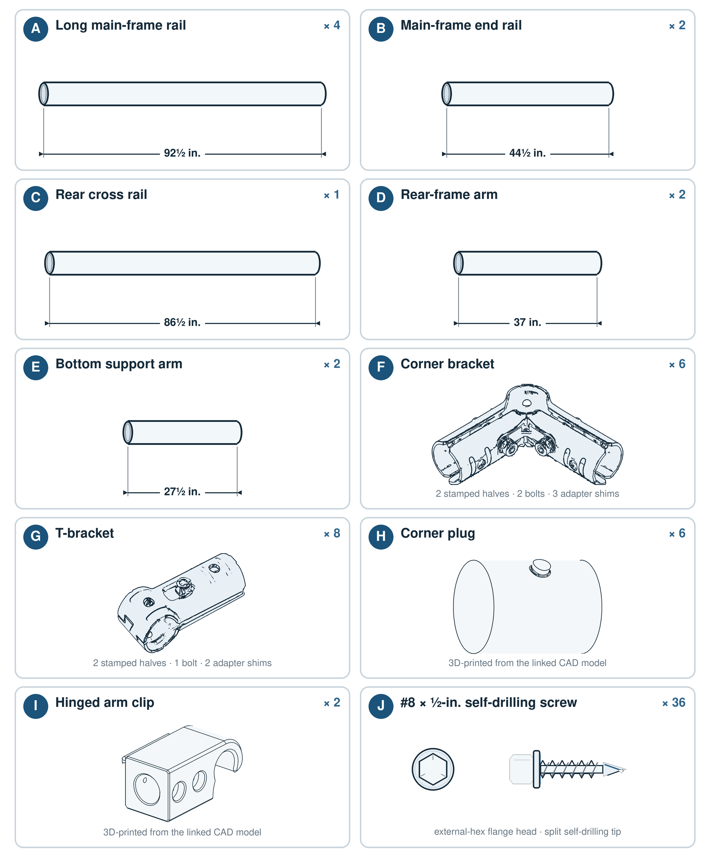
Figure 1. Component inventory for one complete frame.
Identification note: Drawings are not measuring templates and items are not shown at a common scale. The written dimensions and quantities control.

Tools
- EMT conduit cutter
- Tape measure and permanent marker
- Framing square or a tape measure long enough to compare frame diagonals
- Deburring tool or metal file
- 5 mm Allen key
- Drill/driver with a 3/8-in. nut-driver bit
- Eye protection and work gloves
- 3D printer capable of printing ASA, unless the printed parts are prepared in advance

3D-printed parts
Black ASA is the recommended material. Polymaker ASA has provided adequate strength and UV stability in band-prop service for three seasons. PETG may be substituted, but strength varies substantially by brand and formulation; print and load-test a sample before producing all structural parts. Previous Sunlu PETG feather bases fractured in service.
Material restriction: Do not use PLA or ABS for these parts because neither is suitable for prolonged outdoor UV exposure.

Optimized conduit cut plan
The following plan produces every required tube from seven 10-ft stock lengths and does not depend on the nominal 27.5-in. remainder from a 92.5-in. cut. This leaves allowance for normal cutting loss. Keep every finished piece within 1/8 in. of its specified length.
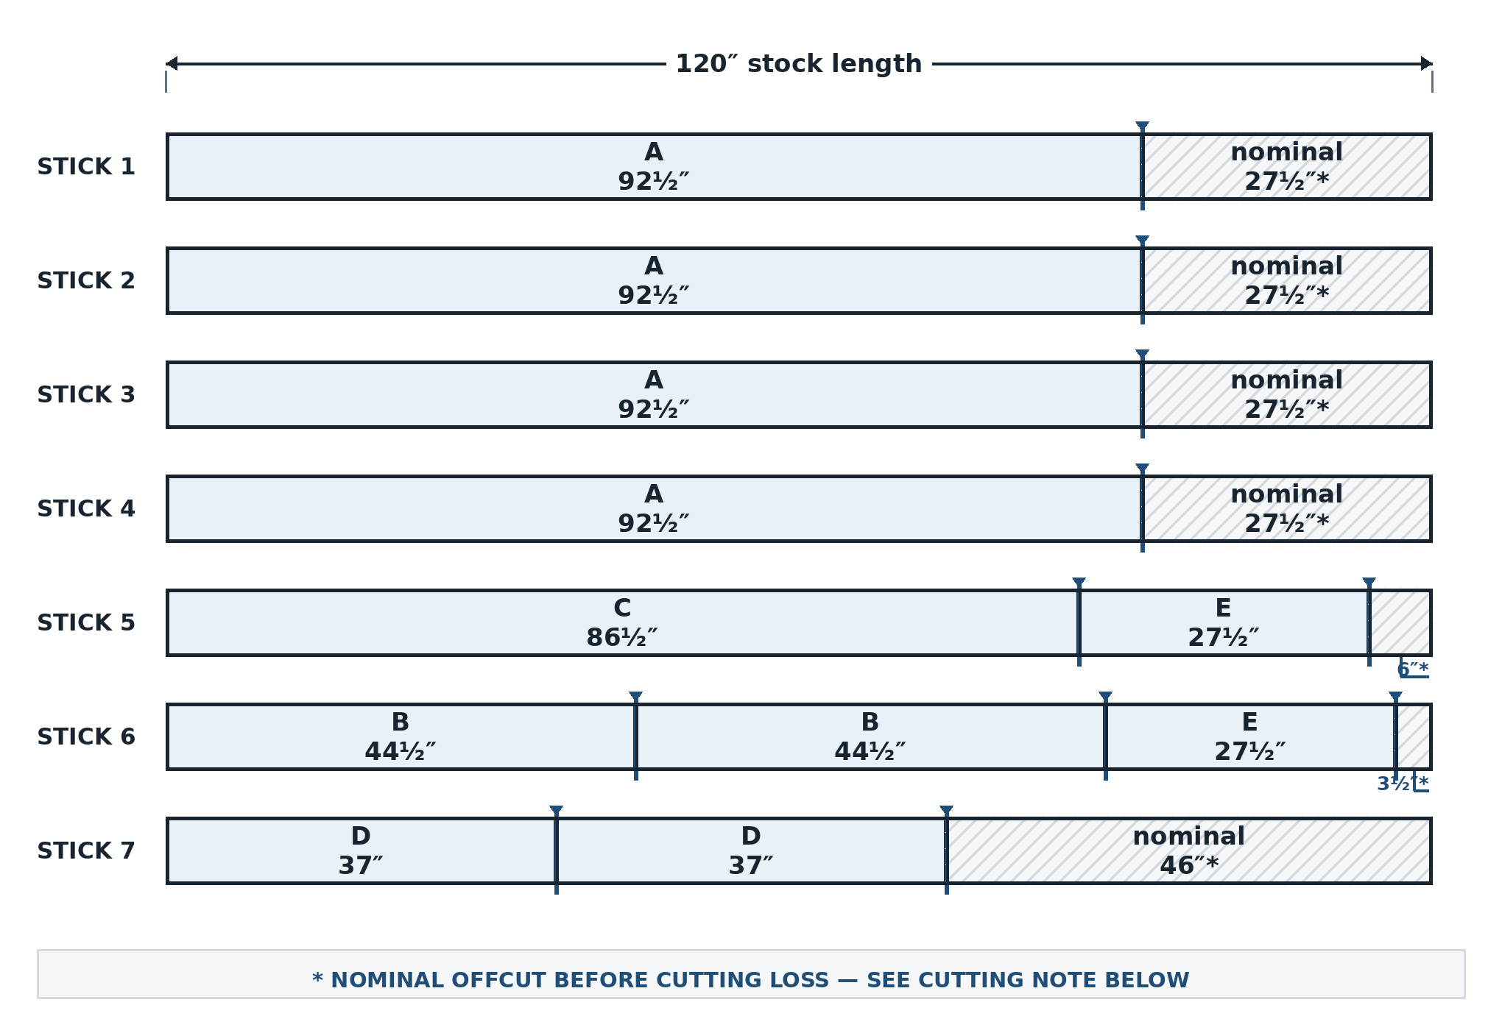
Figure 2. Proportional seven-stick conduit cut diagram.
Cutting note: Gray areas are nominal remainders before cutting loss. Measure every retained piece from a clean stock end. Do not use the nominal 27.5-in. remainder after an A cut as an E arm.

Detailed cut list
Stock length | Retained cuts | Approximate remainder
1 | 1 x 92.5 in. (A) | About 27.5 in.; spare/offcut
2 | 1 x 92.5 in. (A) | About 27.5 in.; spare/offcut
3 | 1 x 92.5 in. (A) | About 27.5 in.; spare/offcut
4 | 1 x 92.5 in. (A) | About 27.5 in.; spare/offcut
5 | 1 x 86.5 in. (C) + 1 x 27.5 in. (E) | 6 in., less cutting loss
6 | 2 x 44.5 in. (B) + 1 x 27.5 in. (E) | 3.5 in., less cutting loss
7 | 2 x 37 in. (D) | 46 in., less cutting loss

Cutting procedure
- Label the seven 10-ft stock lengths 1-7.
- Mark every retained cut before cutting. Verify the complete cut plan before starting.
- Cut each tube to length. Measure the finished piece rather than assuming an offcut is exact.
- Deburr the inside and outside edges of every cut.
- Label the finished tubes A-E so they can be identified during assembly.
When building multiple screens, pool and label usable offcuts before purchasing additional stock.

Frame assembly
Complete the four stages in order. At every hinge location, fasten the bracket to the short moving tube only; never drive a screw into the long rail around which the bracket must rotate.

Folded-state connection map
Use Figure 3 to identify the finished folded arrangement, then use Figure 3A to see how the individual members and connectors align before beginning Stage 1. Both drawings use the same component labels and connector color key. Tube width and separation distances are enlarged for clarity.
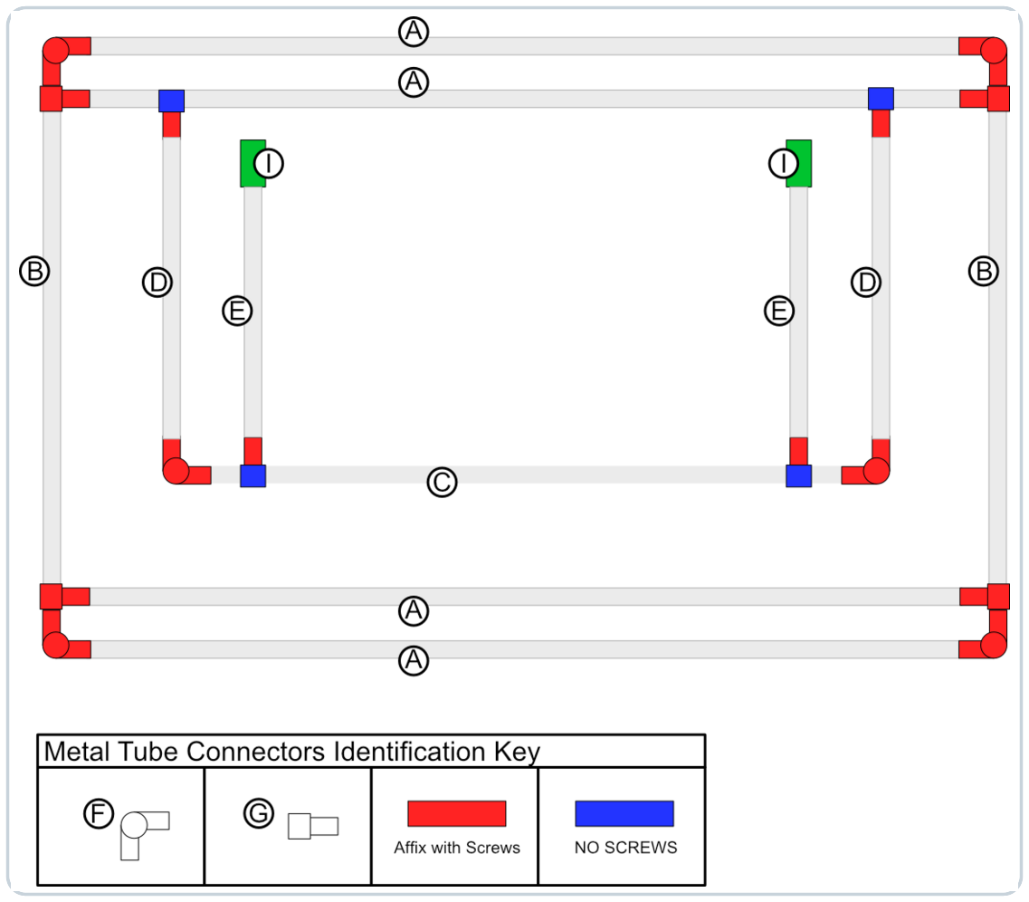
Figure 3. Folded-state component and connector-fastening map for the finished frame.

Exploded folded-state component view
Use this exploded view to identify every construction component in the folded assembly. The separated member ends show how the A-E tubes align with the F and G connectors. Red markers identify connections that receive Item J screws, blue markers identify interfaces that must remain unfastened to pivot, and green blocks identify the two Item I hinged arm clips. Individual Item J fasteners are intentionally omitted.
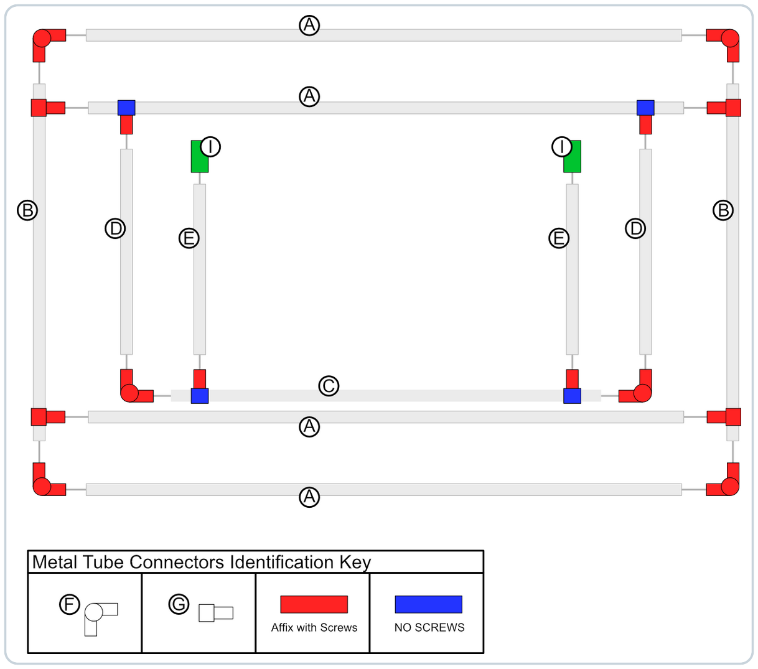
Figure 3A. Exploded folded-state component and connector-fastening map.

Connection rules
Affix with screws — At every red connector marker, secure the connection from the inside or rear face with Item J self-drilling screws, using the quantity and locations specified in the applicable build stage.
No screws — At every blue connector marker, do not drive an Item J screw into the tube that must remain free to pivot. Install the specified screws only on the red-marked fixed side of the connector.
Protect the vinyl — Orient every Item J screw head, T-bracket nut, and bolt tail toward the inside or rear of the assembly, away from the finished face and vinyl.

Stage 1: Assemble the main frame
Parts for this stage
- 2 x A rails
- 2 x B rails
- 4 x F corner brackets
- 4 x H corner plugs
- 8 x J screws
- Lay two A rails and two B rails on the flat work surface to form a rectangle.
- Join the tubes with four F corner brackets. Insert one H corner plug into each unused third socket, rotating it so the side peg faces the rear and aligns with the hole on the bracket's outside bend.
- Measure both diagonals. Adjust the frame until the diagonal measurements are equal, then tighten all bracket-retaining bolts.
- Install one J screw at each of the eight tube-to-bracket joints. Drive the screws from the inside edge of the rectangle so no screw head faces the finished face.
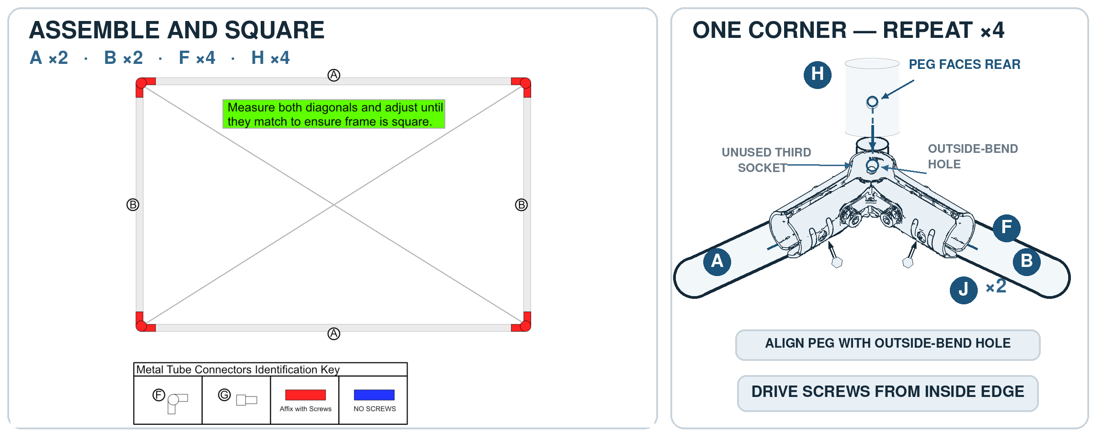
Figure 4. Stage 1 main-frame assembly and corner detail.

Stage 2: Install the inner cross rails
Parts for this stage
- 2 x A rails
- 4 x G T-brackets
- 8 x J screws
Fastener orientation: Place the T-bracket nuts and bolt tails on the rear face. The front/finished face must remain free of sharp projections that could damage the vinyl.
- Place one A rail immediately inside the top A rail and the other A rail immediately inside the bottom A rail.
- Attach each end of both A rails with a G T-bracket. Insert each bracket bolt from the finished face toward the rear so the nut is on the rear face, then tighten fully.
- Flip the main frame so the rear face is up.
- Drive one J screw through each of the eight tube-to-T-bracket interfaces from the rear face.
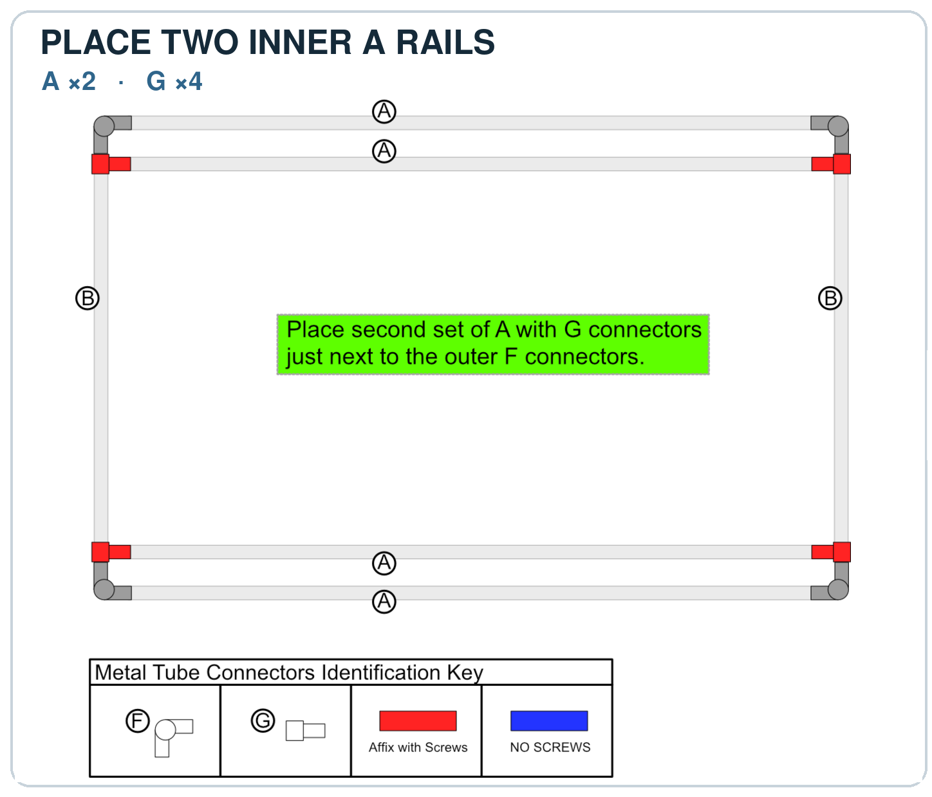
Figure 5. Stage 2 inner-rail placement and T-bracket fastening.

Stage 3: Assemble and attach the rear support frame
Parts for this stage
- 2 x D arms
- 1 x C rear cross rail
- 2 x F corner brackets
- 2 x G T-brackets
- 2 x H corner plugs
- 8 x J screws
Critical hinge rule: Each G bracket in this stage must pivot around the upper A rail. Install two screws in each D arm, but no screws in the A rail.
- Flip the main frame so the finished face is up. No additional self-drilling screws will be driven through the finished face.
- Choose either long edge as the top and mark it. The upper inner cross rail is the second A rail from the top.
- Attach one D arm near each end of the upper inner cross rail with a G T-bracket. Position each new bracket immediately inside the previously installed bracket at that end.
- At each G T-bracket, drive two J screws into the D arm only (four screws total). Do not drive screws into the A rail; the bracket must rotate freely around that rail.
- Join the free ends of the two D arms with the C rear cross rail, two F corner brackets, and two H corner plugs.
- Square the rear support frame and tighten both corner brackets.
- Install two J screws at each rear-frame corner (four screws total), placing them on the inside of the corner. Stage total: eight screws.
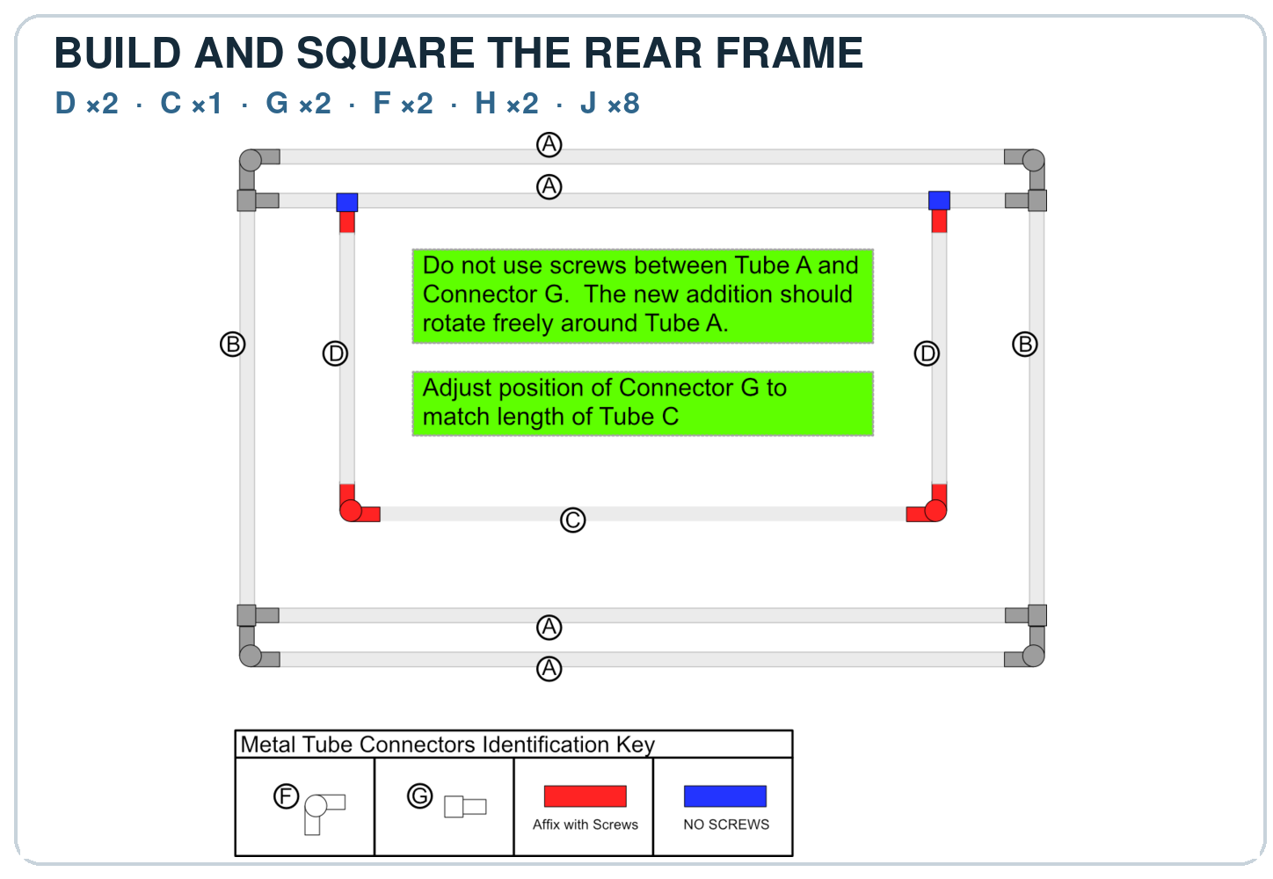
Figure 6. Stage 3 rear-support-frame assembly and hinge fastening.

Stage 4: Install the bottom support arms
Parts for this stage
- 2 x E support arms
- 2 x G T-brackets
- 2 x I hinged arm clips
- 12 x J screws
Critical hinge rule: Each G bracket in this stage must pivot around the C rear cross rail. Install screws in the E arms only; do not fasten either bracket to the C rail.
- Attach one E support arm near each end of the C rear cross rail with a G T-bracket. Position each new bracket immediately inside the adjacent corner bracket and tighten the bracket bolts.
- At each G T-bracket, drive two J screws into the E arm only (four screws total). Do not drive screws into the C rail; the bracket must rotate freely around that rail.
- Stand the assembly upright with both E support arms lying on the ground.
- Fit one I hinged arm clip onto the free end of each E arm. Engage both clips with the lower inner cross rail, which is the third long rail from the top and the second from the bottom.
- Make each clip square to the lower inner cross rail and confirm that it is fully seated on its E arm.
- Drive four J screws through each hinged arm clip into its E arm (eight screws total). Start with the accessible outside pair, disengage the clip, and install the remaining two screws. Stage total: twelve screws.
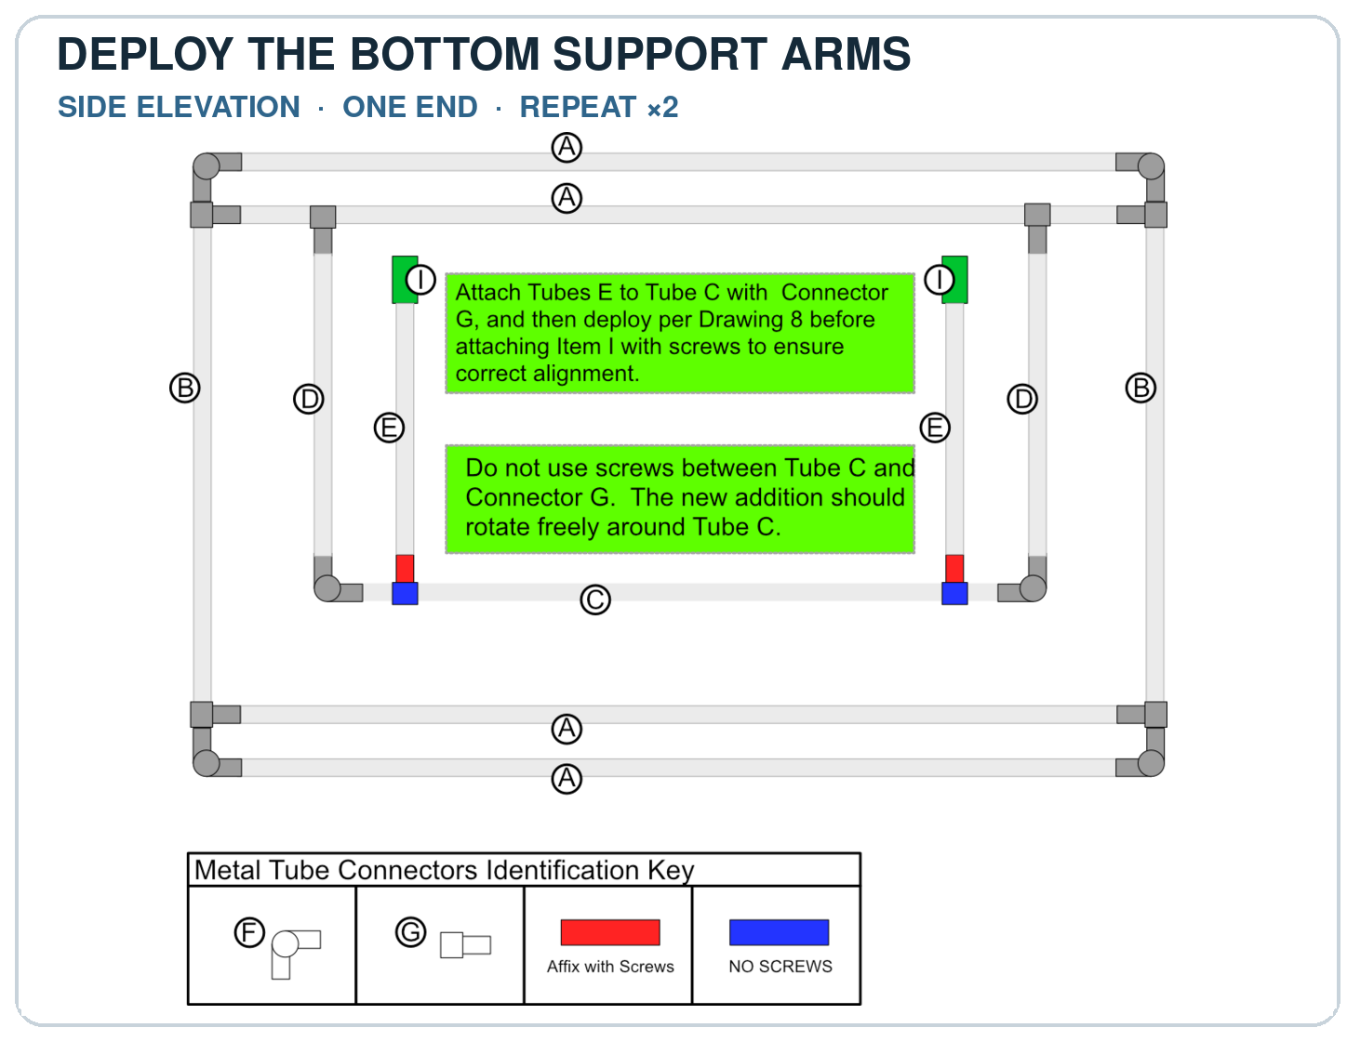
Figure 7. Stage 4 bottom-support-arm installation and clip fastening.
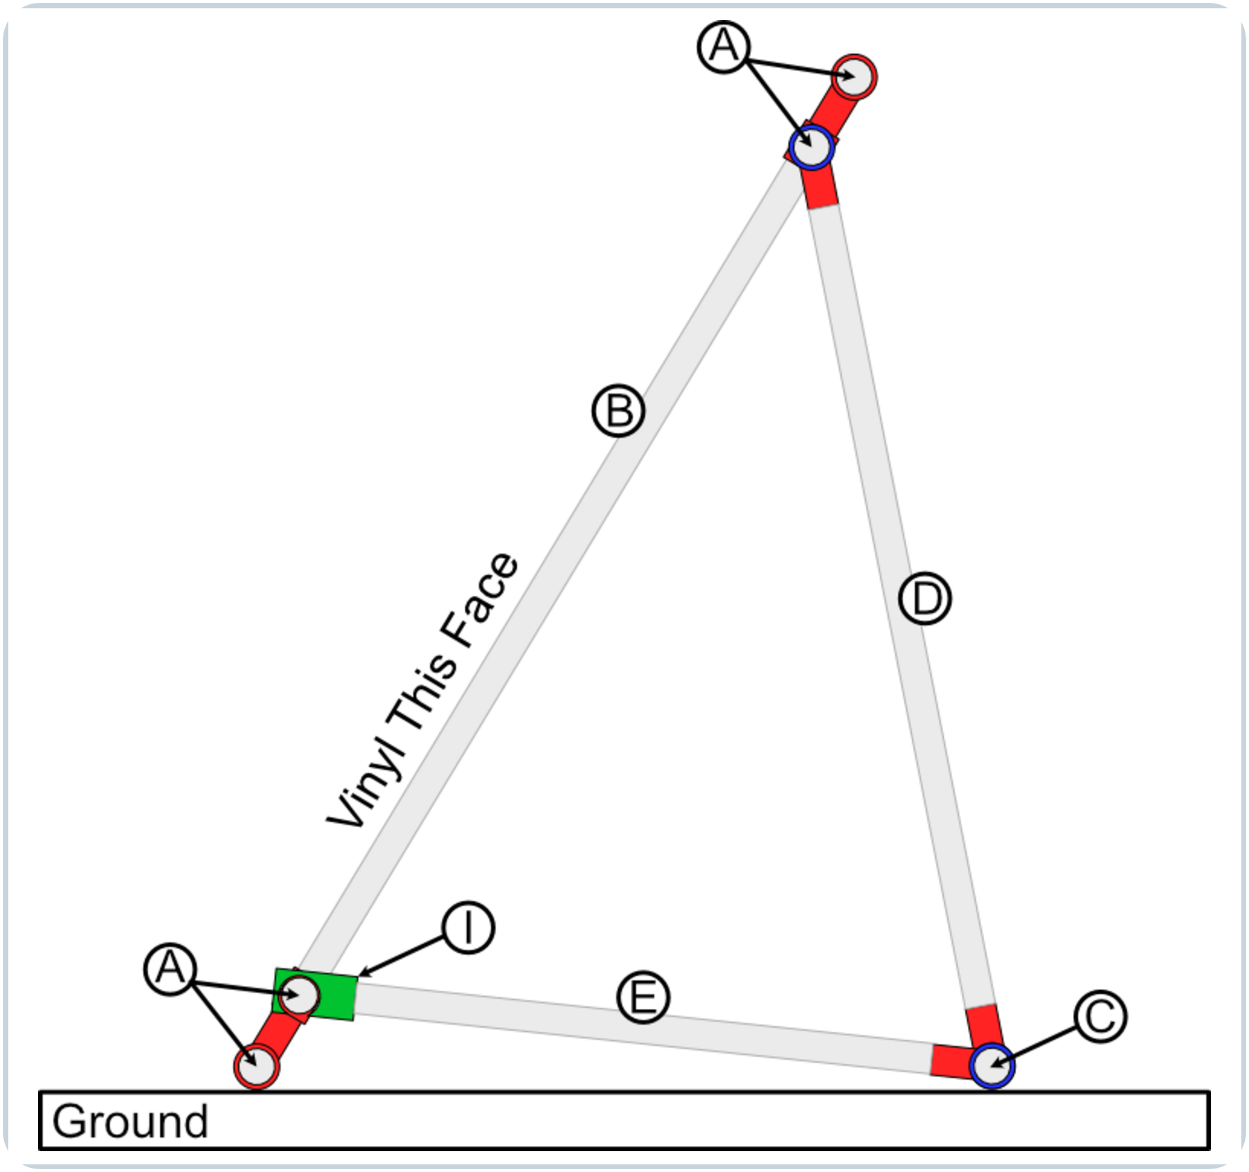
Figure 8. Deployed cutaway side elevation showing the B foot and C/E connection.

Final construction inspection
- All 36 self-drilling screws are installed in the specified locations.
- No screw head, bracket nut, bolt tail, burr, or other sharp projection faces the future vinyl surface.
- Both rear-frame hinges rotate around the upper inner rail without binding.
- Both bottom-support hinges rotate around the rear cross rail without binding.
- Both hinged arm clips engage and disengage without excessive force.
- All retaining bolts are tight, and every structural corner is as square as practical.
- The frame can be unfolded, locked open with both clips, released, and folded flat.

Vinyl Installation
Section status: Reserved for the next development pass. This working draft does not yet provide a complete vinyl-installation procedure.
This section will document vinyl dimensions, cutting, finished-face orientation, attachment hardware and spacing, tensioning and squaring, edge protection, inspection, repair, and replacement.

Appendix B Index
This index applies to Appendix B. Use the numbered references in the Appendix B component table to locate purchase sources, print material, and digital part files. In the digital manual, select a descriptive link. For a printed copy, the complete URL is shown beneath each link.

Purchase sources
[1] 3/4-in. x 10-ft EMT conduit - Home Depot
https://www.homedepot.com/p/3-4-in-x-10-ft-Electrical-Metallic-Tubing-EMT-Conduit-0550110000/202068040
[2] Corner brackets - Amazon
https://www.amazon.com/dp/B0D5BBKCKG
[3] T-brackets - Amazon
https://www.amazon.com/dp/B0CKQW11SJ
[4] #8 x 1/2-in. self-drilling screws - Home Depot
https://www.homedepot.com/p/Teks-8-x-1-2-in-External-Hex-Flange-Hex-Head-Self-Drilling-Screws-280-Pack-21308/100188836
[5] Black ASA filament - Amazon
https://www.amazon.com/dp/B09TR84J5M

Digital part files
[6] Corner plug digital files
FreeCAD source file
https://github.com/ericrowe/music/blob/7ab68c66b4ecbd72d9e039212acab02a002df1bb/PCHSMB/_Sideline%20Screen/Corner%20Plug.FCStd
STEP file
https://github.com/ericrowe/music/blob/7ab68c66b4ecbd72d9e039212acab02a002df1bb/PCHSMB/_Sideline%20Screen/STEP/Corner%20Plug-Part.step
3MF print file
https://github.com/ericrowe/music/blob/7ab68c66b4ecbd72d9e039212acab02a002df1bb/PCHSMB/_Sideline%20Screen/3MF/Corner%20Plug-Part.step.3mf
[7] Hinged arm clip digital files
FreeCAD source file
https://github.com/ericrowe/music/blob/7ab68c66b4ecbd72d9e039212acab02a002df1bb/PCHSMB/_Sideline%20Screen/Hinged%20Arm%20Clip.FCStd
STEP file
https://github.com/ericrowe/music/blob/7ab68c66b4ecbd72d9e039212acab02a002df1bb/PCHSMB/_Sideline%20Screen/STEP/Hinged%20Arm%20Clip-Part001.step
3MF print file
https://github.com/ericrowe/music/blob/7ab68c66b4ecbd72d9e039212acab02a002df1bb/PCHSMB/_Sideline%20Screen/3MF/Hinged%20Arm%20Clip-Part001.3mf

